TRADE FAIR PRE-REPORT FOR PUBLICATION

Leonberg, 18 January 2016

GEZE at FeuerTRUTZ 2016 – Trade fair for preventive fire protection

17 - 18 February 2016, NürnbergMesse, Hall 10.0, Stand 10.0-401


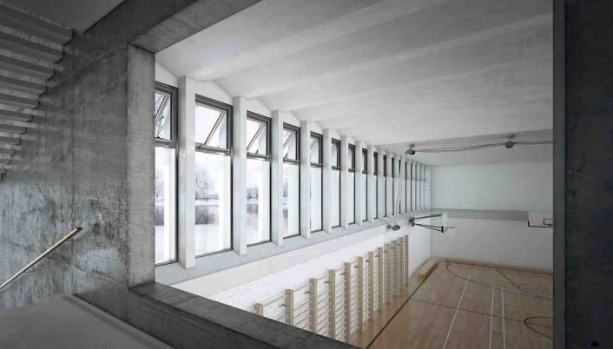
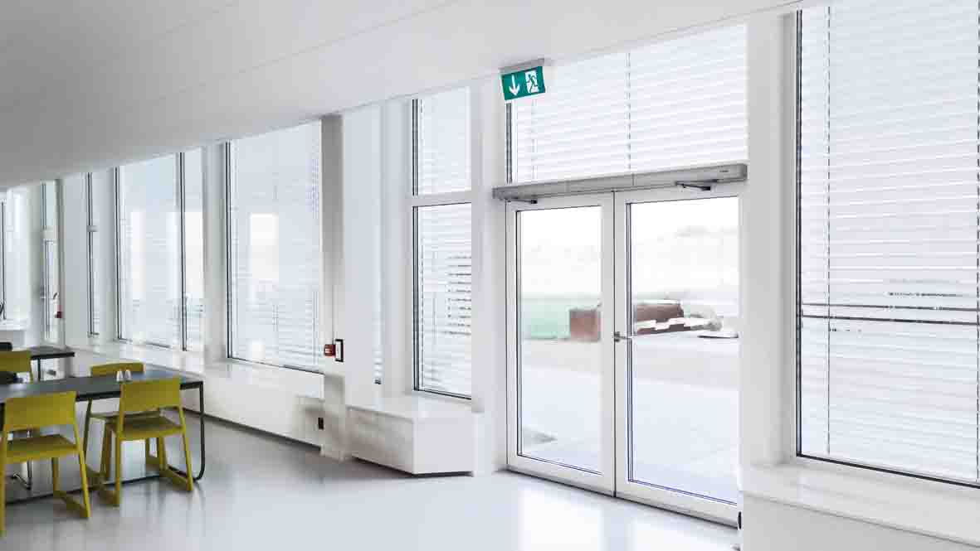

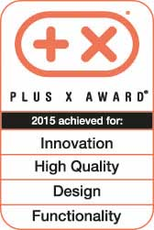

Photos: GEZE GmbH
The "strong" Powerturn swing door drive, awarded two Plus X awards, combines accessibility and functional diversity. It satisfies all comfort and safety standards and is also approved for heavy fire protection doors. | The Powerchain chain drive for large and heavy windows in a smoke and heat extraction system solution The drives in the IQ windowdrive range are equipped with a KNX interface and can be integrated into KNX-based building systems

Innovative strength and systems expertise
GEZE solutions for preventive fire protection on doors and windows

As a specialist and system provider for door, window and safety technology, GEZE will be introducing new and innovative products and systems for preventive fire protection. With system solutions linking different safety and comfort functions on doors and windows, the company is answering the demands of persons responsible for safety, planners, builders and users.

Safety, comfort and flexibility with "intelligent" windows
GEZE automates many different kinds of window and façade elements and presents its modular smoke and heat extraction system (RWA) programme with the intelligent drives of the IQ windowdrive range. State-of-the-art control technology makes the drives flexible and network capable, so that they can be adapted to different requirements for both ventilation and RWA cases. GEZE will present the chain drives Slimchain, the particularly slim all-rounder, and Powerchain, the power package for large and heavy windows. As a direct opener, the E 250 NT spindle drive is the preferred solution for roof windows and skylight domes. Together with the new Powerlock locking drive these drives become a modular system solution from a single source. Powerlock locks and unlocks window elements safely and reliably, thus ensuring smooth interaction between drive and lock. As providers of complete RWA systems, trade fair visitors will also be able to see for themselves the advantages of the small compact RWA control units THZ and THZ Comfort, as well as the modular bus central control unit MBZ 300 for large and complex RWA systems.

The new GEZE indoor climate control for controlling natural ventilation extends the window drive and RWA range. Equipped with an interface based on KNX communication standards, it can be integrated into a KNX-based building system. Other KNX systems and drives or building technology components, such as sun protection systems, heating controls or air conditioning, can also be linked to the GEZE indoor climate control. Individual, flexible and efficient automation, safety and comfort functions and thus various ventilation scenarios can be put into practice with solutions from GEZE

Networking determines the future
GEZE goes one step further towards intelligent building networking and will introduce two new solutions to turn buildings into smart buildings. For this purpose, the company uses two global communication standards, KNX and BACnet, with which different kinds of building technology components can be linked and automated.

An innovation in window technology is the interface module IQ box KNX. It enables direct integration of the IQ windowdrive in KNX building systems to control natural ventilation. The module offers the additional advantage of providing the KNX network with further information about window functions.

All GEZE system components become "networkers" with the new interface module IO 420. Automatic door systems, ventilation technology and RWA as well as safety systems, such as e.g. escape door controls, can be integrated into the superordinate building management system to automate its functions using BACnet.

Multifunctional door systems: The whole range of GEZE system expertise
GEZE demonstrates cross-product expertise with a multifunctional swing door system for escape and rescue route doors. A system highlight is the Powerturn swing door drive for large and heavy doors which is distinguished by its high level of function and design diversity. Other components are the self-locking panic lock IQ lock EL, the door control unit TZ 320 as the core element of escape door control, the escape door lock FTV 320 and the stand-alone access control system GCER 100, which can be operated with tags and car keys. The entire system combines automatic, fully-accessible door comfort, increased anti-burglary protection and safeguarding of escape routes and access control.

GEZE will also show the IQ lock AUT self-locking panic lock from the IQ lock family. Its merits lie in being able to fulfil the whole range of safety and comfort demands made on full panic doors with automatic door leaves on both sides.

The new free swing door closers with comfort hold-open function
GEZE door closers offer combined fire protection and accessibility. The free swing door closers in the TS 5000 and in the integrated Boxer series have another benefit in addition to the free swing function: The unique comfort hold-open function enables doors at the end of the free swing area to be kept locked in position and permanently open. The fire protection function is not compromised in the process.
Press contact:

